Friends of Highgate Surgery PPG

Walking for Health

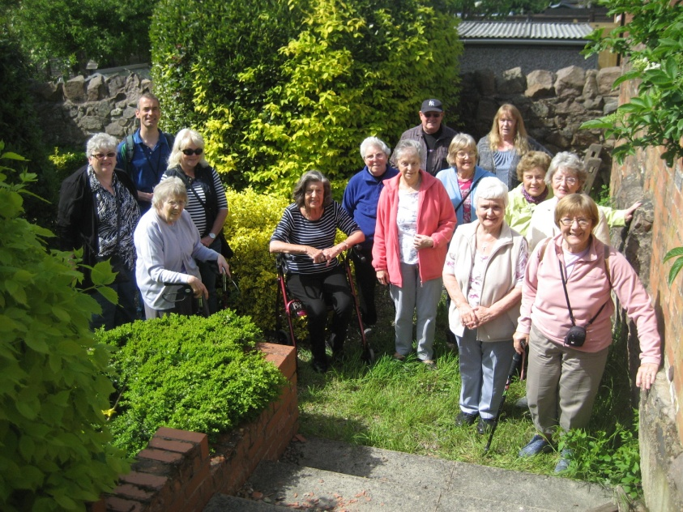

Sileby Community Centre, 2.30pm

Wed 11th May The Peace Garden 1 mile
Wed 8th June Cossington (bus there) 1.25 miles
Wed 13th July Sileby Memorial Park 1 mile
Wed 10th Aug Sileby Mill 1.25 miles
Wed 14th Sept Quaker Road 1.5 miles
Wed 12th Oct Highgate School (bus there) 1 mile

Walks led by Christine and Dave

Everyone Welcome
Sturdy Shoes to be worn
Sorry No Dogs
www.highgatemedicalcentre.co.uk

